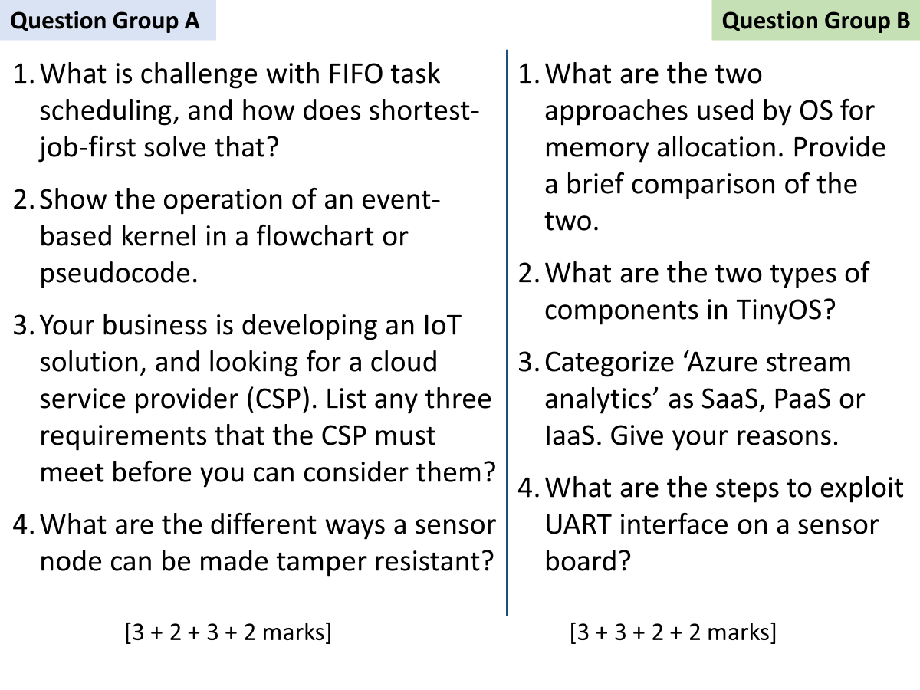

A

1

FIFO scheduling is unfair for small tasks, since a long running task could be at the front of queue blocking everyone else. Average wait time for a task is high.

With SJF, the shorter tasks are scheduled first on the CPU before longer ones, hence on the average the waiting time is small.

2

Loop forever

IF event1 is triggered

Call event_handler1

ELSE IF event2 is triggered

Call event_handler2

……

EndLoop

3

Any three of following

* Support for IoT protocols: MQTT, CoAP, WebSockets, RESTful etc.
* Support for secure remote firmware upgrades
* Web-based and mobile applications for data viewing, processing and remote device control.
* Flexible pricing model

4

L23 slide 12

---

B

1

L21 slide 6

2

Module components - the basic building blocks of a TinyOS program

Configuration components which defines the wiring, how modules are connected with each other

3

Stream analytics is a PaaS because Azure provides the runtime (or the platform) for our analytics processing code.

It is not an IaaS because we do not have to setup our own operating system, We only provide the real-time filtering/processing/analysis code.

4

UART pin identification

identification of baud rate

Use of TTL to USB converter to monitor traffic